Exercises
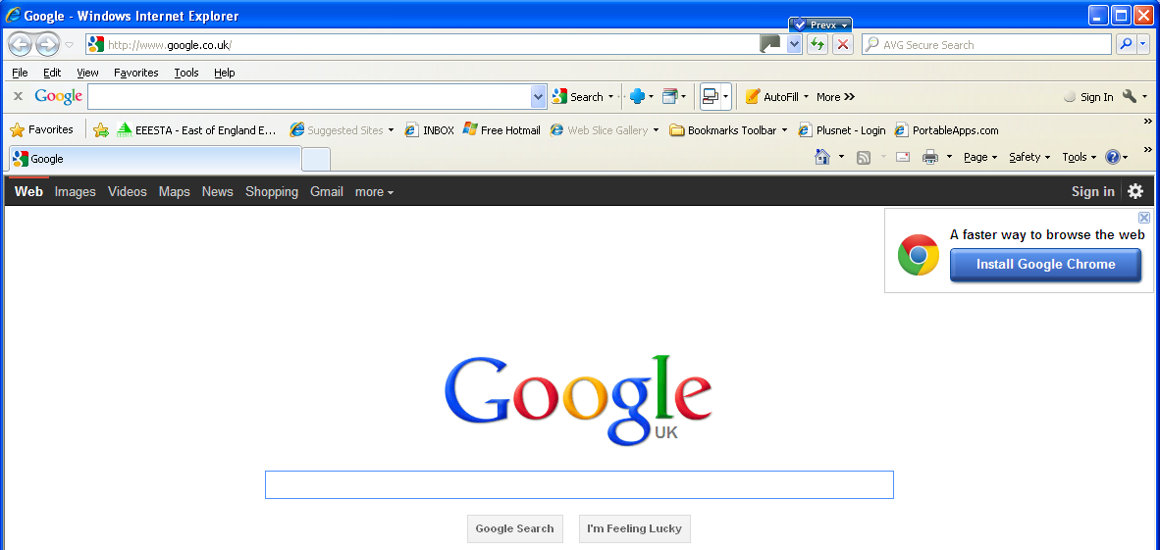
For all the online exercises you will need to run Internet Explorer (IE).
Enter the web address into the Address Box
eg www.google.co.uk
Then press Enter/Return
Google question box
Google Search
Exercise 1 - Who was the last woman hanged in Hull prison?
Enter www.google.co.uk into the Address Box of IE.
When Google starts, enter your question in the question box and click on Google search. When you have found the name of the woman put that in the Google question box and see what else you can find.
Follow the links and record what you find, and the web address of each item.
Hint: Open MS Word and record information and web links in a Word document:-
On the web page: Highlight the text you wish to record
Right click select Copy (or press Ctrl-C)
In Word: Right click select Paste (or press Ctrl-V)
In Internet Explorer: Click into the Address Box to highlight the web address
Right click select Copy (or press Ctrl-C)
In Word: Right click select Paste (or press Ctrl-V)
Save your document with a suitable filename.

Exercise 2 – Where is Wilfred Owen buried?
Open the Commonwealth War Graves Commission website www.cwgc.org
In the Enter Wilfred Owen’s name and initials in the Find War Dead search box.
Hint: use full initials to narrow the search. If necessary use Google first to find his full initials and the war he died in.
Click on Search. If you want you can the filter the search by adding more details.
Follow the links to see his Death Certificate and Cemetery details.

Exercise 3 - Search HALs records to find a Marriage
Open the HALs website www.hertsdirect.org/services/leisculture/heritage1/hals
Click on Online Indexes and Catalogues
Click on Search Hertfordshire Names Online (at the bottom of the page)
Click on Marriages (1538 - 1922) in right hand Advanced search box, when the next window opens insert Poulton in the Male surname box and St Albans Abbey in Place box, then click on Search.
Exercise 4 - Find distribution of your family names in 1881/1998
Enter http://gbnames.publicprofiler.org into the Address box of IE.
Click on Search for a Surname
Choose a Year (1181 or 1998). Enter surname. Click on Find.
Go back and choose a different year to see how the distribution changes. Try another surname.

Exercise 5 - Files & Folders: Create a new folder on your memory stick
Insert your Computer Friendly Family History Course Material memory stick into a USB slot on the computer.
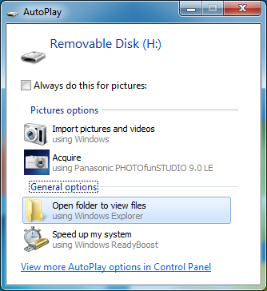

An Autoplay window will pop up. One of the options displayed is ‘Open folder to view files’. Click on this.

Note: ‘Autoplay’ may have been disabled on the computers used on this course, if so it will not open.
Click on Start > My Computer > Removable Disc
Alternatively, hold down Windows key  (bottom row of keyboard) and at the same time press letter ‘E’ - this instruction will also be given by press [Win-E]. Select Removable Disc.
Now click on New Folder on the menu bar of the window. You will see the new folder with “New Folder” highlighted in blue.
Just start typing your name*, without touching the mouse. Your new folder is created with your name on it! * It is recommended that you have a separate folder for each branch of your family.
Double-click on this folder to open it. The folder will open and you will see that there is nothing in it at present, but this is where you will save your family history records.
Close the folder by clicking on the cross in the top right corner.
It is recommended that you have a file and folder naming scheme that makes sense to you, and enables the computer to sort everything automatically into name and date order. A good scheme is to use words followed by dates in YYYYMMDD format: eg ‘Surname’,‘First name’,’event’(eg census, dob etc),date. For example, you could store all the census records in a folder named surname,firstname,censuses where the person named is the head of the family in that series of censuses, and the date is the first census, eg Williamson,Walker,census1881.
Note: On your home computer it would be sensible to have a folder called “Family History”, or some other name of your choice, to keep all your family history records in one place and separate from any other files and documents.
Exercise 6 – Draw a simple family tree
Draw a simple family tree of your immediate family, as shown in the drawing on page 7: print a blank drawing from Simple family tree.pdf, which is on your Computer Friendly Family History Course Material memory stick. Place your parents in the centre, with their parents above and you and your siblings below. In the shapes, or adjacent to them, insert all the life facts that you have, DOB & where etc.. The name in the Family Tree of is the name of the father at the centre of the tree.
Do this for every family group that you discover in your researches.
Exercise 7 – Start a Pedigree Chart
Print a copy of the Pedigree Chart shown on page 8: print from PedigreeChart.pdf which is on your Computer Friendly Family History Course Material memory stick.
Start with you and work backwards, inserting information about your ancestors as shown on the chart. Add to this chart as you find more information. Use a pencil so that you can correct any errors.
Exercise 8 - Enter your family data on Scion
Please read Appendix 5ScionPC employs a simple  model...
- Add people to the database (creating Personal Details Pages)
- Join couples to create family groups (creating Family Details Pages)
- Add children to the family groups (using Family Details Pages)
Open the Scion folder on Computer Friendly Family History Course Material memory stick.

Click on the Scion shortcut to start the program: it will open with the following window.

Step 1. Add people to the database
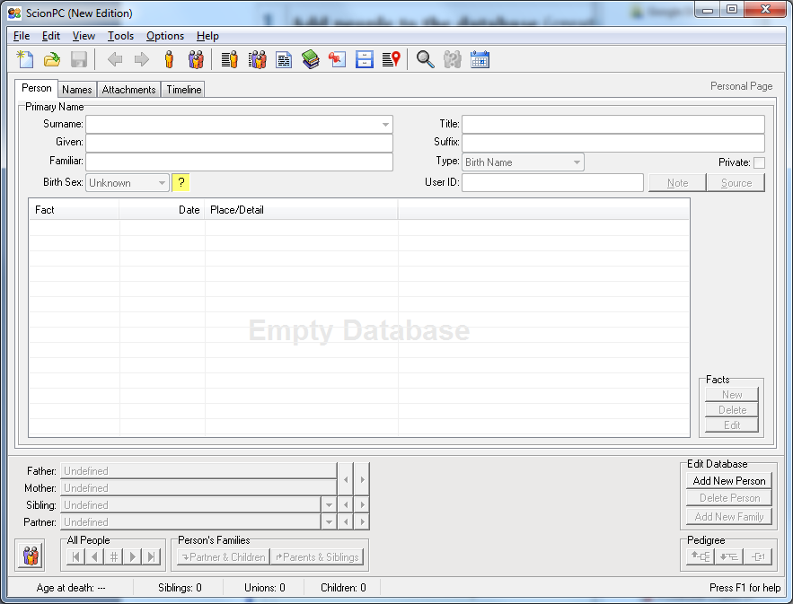

Start with yourself and add as much information as you can.
Click on Add New Person

Enter your names etc

Click on New Facts to add important events in the Fact Details window.

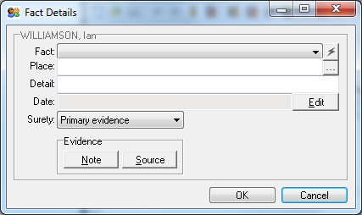
Click on the Fact down arrow to select the event, eg Birth, Baptism, Death and many more.
Note: Marriage is not included in this list of Facts.
Enter Place details.
Click on Edit to enter Date (in numbers)
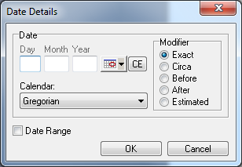

Save the file before you go any further. Click on File > Save As, enter a file name in that box, select where you want to save the file (see Exercise 5) and then click on Save.
When you save a file, or load an existing file the blue bar at the top will show the file name.
Note: As the program is not installed on the computer, you will note that the file has been saved without a file icon, and when you want to load the file on another occasion you can’t just click on the file icon, you will have to start Scion and then Open the file.
Click on Add New Person, eg your father, and add all his details as above. Do exactly the same for your mother, and other members of your family. Continue adding as much information as you can about your ancestors as individuals. Once you have added a few people who formed couples you can go to the next step and join them to make family groups.
Step 2 - Join couples to create family groups (creating Family Details Pages)
See Appendix 5.2 Follow instructions to join your parents as a family group. Then add children.
Step 3 - Add children to the family groups
See Appendix 5.3 Follow instructions to add children to your family group.
Repeat this process for all your ancestors. Add ancestors and their personal data, family groups and children as you discover them in the course of your family history research. You can add and correct any information about any of your ancestors as/when you find it.
When you have finished a session, click on Save icon on the top bar, and then the Cross in the top right corner of the window to close the program. A Confirm window opens asking if you want to save any changes to the database: click on Yes.
Exercise 9 - Explore 1911 Census for someone in your family
Go to the Google web search home page, www.google.co.uk. Enter 1911 census
Click on Welcome to the official 1911 Census website. Select Search the 1911 census
Enter name of the person you are looking for, ideally with date and place of birth
Click on Search. A new window will open showing the person search results
Scroll down the page. You will see that to view transcripts cost 10 credits, and to view original pages costs 30 credits. Credits cost £ 6.50 for 60 (min purchase) but you will not be charged for transcripts or original pages that you have already purchased and are in your "my records".
Rather than pay, use www.ancestry.co.uk as Computer Friendly has an account (see Exercise 11).
Exercise 10 - Explore FreeCEN for someone in your family
Go to the FreeCEN search home www.freecen.org.uk
Scroll down to the bottom of the page and click on Search the Database
Enter name of the person you are looking for with as much information as possible. Click on Find.
Don’t worry if you see “Sorry, we found no matches” as this site has only about 40% coverage. Don’t spend much time looking, Ancestry.co.uk is more useful.
Exercise 11 - Find Alfred T Brown in the 1901 census
Log onto www.ancestry.co.uk - not .com as that is the USA site.
Enter username and password (you would need to do that at home, but not on this course)
Select 1901 census. Enter Alfred T Brown, Birth year 1898, Location Lincolnshire.
Click on Search (you may have to scroll down the page to see the Search button)
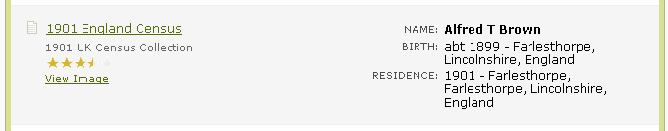
Find the correct person from the results of the search

Hover your cursor over 1901 England Census and you will see a Preview window.
Click on 1901 England Census and you will see all the other members of the family, and their ages. You can also view an image of the original census entry, and the address of their home.
Important. Keep detailed records of your findings and where they were found. Information and images can be printed or saved to your PC. A record of a search can be saved by Ancestry, Click on Save at the bottom of the page.
Note: the handwriting of the enumerator can be quite difficult to read, and mistakes have been made when transcribing data to the census search websites, so it always pays to view the image of the original census entry to be sure that you have accurate information.
Exercise 12 - Find Alfred T Brown’s father in previous censuses
You did keep a record of the details of Alfred T Brown’s family didn’t you? Select 1891 census
Enter his father’s name, Birth year, and where born in the relevant boxes.
Click on Search and follow the instructions in Exercise 6 to see and record all the other members of the family. Repeat this process in the 1881, 1871, 1861 and 1851 censuses if you can.
Exercise 13 - Find a member of your family in 1901 and earlier censuses
Chose a family member who you know was alive in 1901. Enter their name, Birth year and place into 1901 census search page, as in Exercise 6.
Hint: too much information may not help as it may restrict the search so much that no relevant results are shown, try first of the first names, or just the initial of the first name.
Remember the problem with spelling of names.
Work backwards through earlier censuses, as in Exercise 7. Save your results.
Exercise 14 - Find the Birth Certificate for a member of your family
Log onto www.ancestry.co.uk
Select Search and then Birth, Marriage & Death
Enter First & Last Name, Year and Location
Click on Search and then select the most likely result
Save record and note the registration details.
Repeat the exercise using FreeBMD www.freebmd.org.uk
Select Search and then Births, enter all the details then click on Find.
Exercise 15 - Find the Marriage Certificate for a member of your family
Using either/both www.ancestry.co.uk and/or FreeBMD www.freebmd.org.uk
Find the Marriage Certificate for one of your relatives by the method used in Exercise 10.
Note the name of the spouse.
Save record and note the registration details.
Exercise 16 - Find the Death Certificate for a member of your family
Using either/both www.ancestry.co.uk and/or FreeBMD www.freebmd.org.uk
Find the Marriage Certificate for one of your relatives by the method used in Exercise 10.
Save record and note the registration details.
Ordering certificates from GRO
This is not an exercise we will do on this course, as you will need to set up an account with GRO and give your credit card details, and you may prefer to do that in the privacy of your own home.
Double click on Useful websitesV3.doc, which is on your Computer Friendly Family History Course Material memory stick. That will open in MS Word, and all the links are active. Go to Link 17, [Ctrl-click] on that link and follow the instructions.
Exercise 17 - View Examples of Scottish BMD Records
Log onto ScotlandsPeople http://www.scotlandspeople.gov.uk
Select About our records and then Record examples
Click on Statutory Registers SR Births, Marriages or Deaths (right hand menu).
Click on Example of an 1855 BMD image and see how much more information you get about:
- the birth and the parents than from English birth certificates.
- the couple and both sets of parents.
- the deceased person and parents.
Finally, for a detailed breakdown of the information you can expect to find on Scottish B, M & D records, click on Images on any of the pages you had viewed (or go to http://www.scotlandspeople.gov.uk/content/help/index.aspx?r=554&628)
Exercise 18 - Find an elusive member of your family
In this exercise, use any of the online databases to find a member of your family who has been difficult to find, or for whom you are missing vital information.
For example, see if they have been listed on any of the websites covering people with the same name (Links 30-33) or link people to places (Links 34-36). Does your ancestor have a military record (Links 48-50) or a criminal record (Link 45-47)? Search for ancestor on one of the online family trees (Links 37&38), start with GenesReunited.
Carefully record everything you find and where you found it, so that you can find it again. Enter the data on your file on Legacy.
Exercise 19 - Start a family tree online
Go to Genes Reunited http://www.genesreunited.co.uk.
Click on Start your family tree now, when the Register for FREE window opens, enter your details and a password (keep a record of your password!), tick/untick boxes as you wish, but click that you have read and agree to the terms & conditions etc. Then click on Register Free.
Your tree will begin with you as the tree owner. The page is divided into two parts. At the top is your tree and at the bottom you can see the details for yourself.
Start to add names to your tree by clicking on Add Partner, Add Child, Add Mother/ Father or Add Sibling. After you have added the details to your tree click on 'save'. When adding a child to your tree you must always have an entry for both parents. You will still need to add a year and place of birth. For the year you could estimate this and then tick the box to show it is not accurate.
You can then move around your new tree by clicking on a person and then adding in their immediate family. Remember to click on 'save' whenever you add new information.
If you have recorded family information in a family tree program, export a GEDCOM file.
Go to Genes Reunited, click on the Family Tree button at the top of your homepage. Select Gedcoms from the drop-down menu to go to the import/export gedcom page. The site will add relations in your tree from information exactly as it is stored in your Gedcom file.

